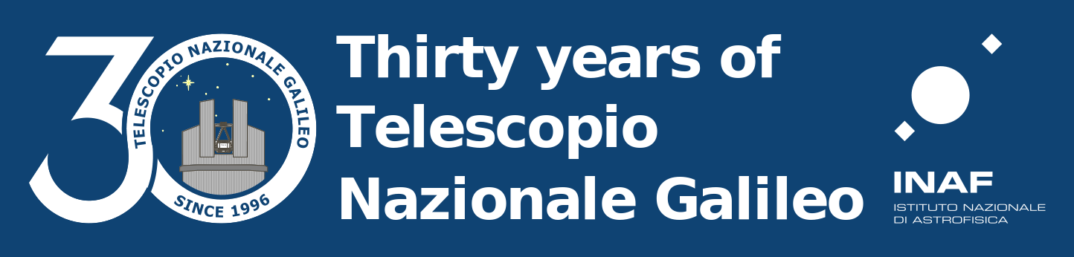

PHOTOGRAPHY CONTEST

“30 Years of TNG in La Palma”

1. Organization
Fundacion Galileo Galilei – INAF, a non-profit organization responsible for operating Telescopio Nazionale Galileo (TNG) at Roque de los Muchachos in La Palma, announces the photography contest “30 Years of the TNG in La Palma” on the occasion of the 30th anniversary of its inauguration.
The aim of the contest is to showcase the qualities of the TNG, promote photographic creativity, and build a diverse visual archive for use in its corporate, promotional, and editorial publications.

2. Participants
This is an open competition for both amateur and professional photographers. Participation is open to all natural persons over 18 years of age, of any nationality, who are the authors of the submitted photographs and who fully accept these rules.
As this contest includes cash prizes, employees of the Fundacion Galileo Galilei, members of the jury, and their relatives are not eligible to participate.
Participation is free of charge.
Participants’ personal data will be processed exclusively for the purpose of managing participation in the contest and awarding prizes, in accordance with Data Protection Law and the GDPR.

3. Theme and Technique
Submissions must adhere to the proposed theme: Telescopio Nazionale Galileo.
Entries will be evaluated based on technical and aesthetic quality, realism, originality, relevance to the theme, and suitability for use in online or printed publications. Photographs may be in color, black and white, daytime, nighttime, etc.
Submission requirements:
- Images must have a minimum resolution of 10 megapixels without interpolation. Preferably, they should be submitted in TIF format with an AdobeRGB color profile to facilitate printing if selected. If participants do not have the necessary knowledge to use this format, images may be submitted in JPG format with a standard sRGB profile.
- Files must be uploaded to the shared folder linked at the end of this document. It will be configured so that only the jury can access the submitted images.
- The submission deadline is July 20, 2026, at 14:00 GMT.
- Each photographic file must be accompanied by a .txt file with the same filename as the image, containing the photographer’s name and contact details.
Photographs generated by artificial intelligence or composed of two or more images will not be accepted. Selected images will undergo a verification process and will be disqualified if they fail to meet these requirements. Digital editing is permitted, provided that both the original image and the final result have been created by a human. The organization reserves the right to request the original or RAW file to verify authorship and confirm that no generative AI or image compositing has been used. Failure to provide this file will result in automatic disqualification.

4. Works
- Each participant may submit up to 5 photographs.
- Photographs must be original and must not have been previously awarded in other competitions.
- All images must be the participant’s own work. Photographs authored by third parties will not be accepted.
- Participants are responsible for any claims related to image rights, authorship, data protection, or any other rights involved.
- Images must not contain offensive, illegal content or violate third-party rights.

5. Copyright and Usage Rights
Participants retain the intellectual property rights to their photographs.
By entering the contest, authors grant Fundacion Galileo Galilei a non-exclusive, worldwide, and perpetual license to reproduce, display, distribute, and publicly communicate the selected photographs, solely for use in its own publications or those of its parent organization in Italy (INAF), in both print and digital formats (website, social media, catalogs, reports, promotional materials, etc.). Photographs may be cropped or modified to fit the required publication format.
In all cases, authorship will be respected, and the photographer’s name will be credited whenever possible.
Participants remain free to use their photographs for any other purposes.

6. Selection and Jury
The jury will consist of two members of the Fundacion Galileo Galilei with experience in photography, and Riccardo Bonuccelli, a professional photographer who has previously collaborated with the Istituto Nazionale di Astrofisica (INAF). The jury will select the three winning entries and the photographs to be included in the archive. The jury’s decision will be final.

7. Prizes
The prize fund will be distributed as follows:
- First Prize: €1,125
- Second Prize: €750
- Third Prize: €375
No participant may receive more than one of the top three prizes.
Additionally, multiple smaller prizes of €35 each will be awarded to other selected photographs.
All participants will receive a token of appreciation in the form of Telescopio Nazionale Galileo merchandise.
A selection of the chosen photographs will be exhibited as part of the events marking the 30th anniversary of the TNG’s inauguration, to be held in September.
All selected participants will be invited to take part in a guided tour of the Telescopio Nazionale Galileo facilities, with the date to be announced during the 30th anniversary celebration events.
The organization reserves the right to withhold any prize if the submitted works do not meet the required quality standards.
Prizes are subject to applicable tax withholding under Spanish tax law (Personal Income Tax – Law 35/2006 and Royal Decree 439/2007).

8. Announcement of Results
Winners and selected participants will be contacted directly, and the results will be published on the Telescopio Nazionale Galileo website and its social media channels in early august this year.

9. Liability
Participants guarantee that the submitted photographs are their own work and that they have obtained all necessary permissions from any individuals appearing in them. The organization accepts no liability for any breach of this requirement.

10. Acceptance of the Rules
Participation in the contest implies full acceptance of these rules.
The organization reserves the right to modify any aspect of the contest for justified reasons, undertaking to communicate any such changes appropriately.

Contact Details

Fundacion Galileo Galilei
mgonzalez@tng.iac.es (subject “photo contest”)
Rambla José Ana Fdez Pérez 7
38712 Breña Baja, La Palma

Submission folder link:
- https://cloud.tng.iac.es/index.php/s/ddeXLT8yACiNDAf

Personal Data Protection Clauses

- Data collected: full name, ID number, email address, postal address, and bank account details (if selected).

- Purpose: management of the contest, publication of winning photographs, and awarding of prizes.

- Data sharing: only with relevant tax authorities.

More information on privacy and personal data processing:
http://www.tng.iac.es/lopd

